Case Study

The Cost of media coverage of London 2012
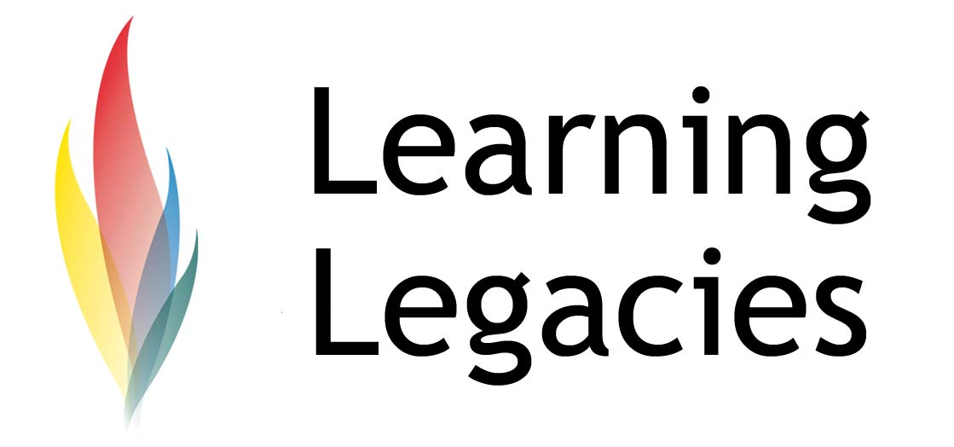

The London 2012 Games could be considered the greatest show on earth – at least, it will be, for the British Broadcasting Corporation (BBC). The 2012 Games constitute the largest event that the BBC has ever covered in its 85 year history.

Games coverage includes an extension of the BBC Three’s usual evening hours of broadcasting during the tenure of the Olympic Games (a total cost of £4.5million) in order to enable daytime sports coverage, a temporary addition of another digital channel for Channel 5 in order to extend coverage, and an expansion of the video capabilities of the BBC website. The extended BBC Three coverage (combined with scheduled BBC1 coverage) is enabled in part by the temporary use of BBC Parliament bandwidth. This approach was already used successfully during the BBC’s coverage of the Beijing 2008 Games.

The BBC voiced their belief that 2012 Games coverage is, to date, their most ambitious strategy ever, and that they are committed to doing justice to the event. They do, however, voice their commitment to the British viewer who is not sports-mad, and who does not want to see their favourite programmes compromised by the event. Television coverage is accompanied by a raft of digital services, including 1000 hours of online video content via the BBC website, and extensive radio coverage. New digital radio station Five Live Olympics Extra has been created especially for the 2012 Games coverage, and will run alongside existing Five Live and 5 Live Sports Extra broadcasts. The cost of the new digital radio station is approximately £200,000.
Post 2012 Olympic Coverage

The International Olympic Committee (IOC) has, however, voiced concerns that the BBC may end its commitment to the coverage of the Olympic Games after the 2012 Games have been completed. Broadcast rights that reach beyond 2012 have yet to be negotiated. Such a concern is particularly pertinent to the IOC, given their reliance on media broadcasting revenues as a key source of their income. The global financial crisis appears to have worried those in the senior echelons of the IOC due to the fact that it might affect the ability of private sector corporations to invest in lucrative broadcasting deals. Such difficulties might force down the value of Olympic broadcasting rights in the long run.

Such concerns appear to be founded – at least in the case of the BBC. For example, the BBC has imposed a budget cut of 20% on its overall costs, meaning that the sports rights budget (currently standing at £300million a year) might become severely compromised. The BBC previously paid around £60 million for the rights to cover the 2010 and 2012 Games and has voiced its reluctance to exceed that figure for 2014-16 coverage. The outcome of such cuts might be that the IOC either has to accept the effects of the budget cuts (parlayed into a lower overall payment by the BBC) or – more likely – will seek to offer the rights to a rival broadcaster. Sky seems to be a major contender within this scenario, as it has already forced the BBC to lose its exclusivity rights to cover

the Masters Golf Tournament. The BBC also failed to tender for rights to cover the Football League and Carling Cup live rights from 2012-13. Rivals Channel 4 outbid the BBC for the rights to broadcast coverage of the 2011 World Athletics Championships and for the coverage of the Paralympic Games.

Furthermore, there is speculation that the BBC’s £200 million 5-year Formula One deal might also be abandoned, in addition to the fact that it has not yet negotiated broadcasting rights for either Sochi 2012 Winter Games or Rio 2016 Summer Games.

The impact of the economic downturn has also raised questions over whether the IOC will be able to maintain the current value of television rights in the coming years. The BBC and other long-term partners indicated that coverage of Vancouver and London Games – worth £1.2 billion – is likely to generate a £245 million loss. This has the effect of leading to a deflation of value of the IOC broadcasting rights. However, the competitive US television market, made up of many financially robust and powerful networks (including ABC, Fox and ESPN), may allow current IOC values to be maintained.
The IOC & the European Broadcasting Union
Prior to the Beijing 2008 Games, the IOC had negotiated British rights via the EBU (European Broadcast Union) that together constituted 75

Case Study

The Cost of media coverage of London 2012
national broadcasters (including the British BBC, ITV & Channel 4). These rights extended to

coverage of the Vancouver 2010 and London 2012 Games, and was worth around £370 million. The

‘Big 5’nations of the EBU (France, Germany, Italy, Spain & the UK) contributed 80% of this figure.

The IOC decided to revisit this strategy, and to negotiate directly with the BBC in 2008 onwards as they felt that negotiating directly with major markets (namely, the Big 5) would allow them to gain more lucrative deals. NB as Sky is not a free-to-air service, it was ruled out of negotiations.

The IOC need to renegotiate terms with the BBC in 2013. It remains to be seen whether the BBC will have any major competition for broadcasting rights. If they do not, the IOC will significantly lack leverage in negotiation and the cost of acquiring the rights might effectively be devalued. Whilst the BBC remain committed to the Games, they are unable to do so at any price, particularly given the austeric climate that Britain and the UK currently face.

BBC Trust Olympic Strategy

In summary, the BBC Trust have outlined three key commitments within their overall Games-coverage strategy that will allow them to develop the most comprehensive and high quality Olympic coverage possible:
1. The extension of BBC Three's broadcasting hours during the 2012 Games;
2. The creation of Radio 5 Live, a digital radio service that will extend existing provisions to allow a comprehensive radio coverage of sports events during Games-time; and

3. The temporary expansion of the BBC website capabilities to allow a significant extension of the capabilities of the website to store a high number of videos. This will allow the public to access sports coverage online to a far greater extent than previously possible.
Further Information
- Maguire, J., Butler, K., Barnard, S, Golding, P. (2008) Olympism and Consumption: An Analysis of Advertising in the British Media Coverage of the 2004 Athens Olympic Games. Sociology of Sport Journal, 25, pp. 167-186.

- Kristiansen, E., Vidar Hanstad, D., Roberts, G.C. (2011) Coping with the Media at the Vancouver Winter Olympics: “We All Make a Living Out of This”. Journal of Applied Sport Psychology . 23, 4.

Discussion
- Consider the potential exploitation of positive Olympic media coverage as a means of gaining acceptance for nations and regimes that have previously encountered claims of human rights and civil rights violations.
- What are considered to be the most significant

Case Study

WOMENS PARTICIPATION IN THE OLYMPIC GAMES
threats to the BBC’s coverage of the 2012 Games?

Case Study

The Cost of media coverage of London 2012

WOMENS PARTICIPATION IN THE OLYMPIC GAMES

This resource was produced as part of the 2012 Learning Legacies Project managed by the HEA Hospitality, Leisure, Sport and Tourism Subject Centre at Oxford Brookes University and was released as an Open Educational Resource. The project was funded by HEFCE and part of the JISC/HE Academy UKOER programme. Except where otherwise noted above and below, this work is released under a Creative Commons Attribution only licence.

Case Study

The Cost of media coverage of London 2012

2012 Ticketing Strategy

WOMENS PARTICIPATION IN THE OLYMPIC GAMES

Exceptions to the Licence
The name of Oxford Brookes University and the Oxford Brookes University logo are the name and registered marks of Oxford Brookes University. To the fullest extent permitted by law Oxford Brookes University reserves all its rights in its name and marks, which may not be used except with its written permission. The JISC logo is licensed under the terms of the Creative Commons Attribution-Non-Commercial-No Derivative Works 2.0 UK: England & Wales Licence. All reproductions must comply with the terms of that licence.

The Higher Education Academy logo is owned by the Higher Education Academy Limited and may be freely distributed and copied for educational purposes only, provided that appropriate acknowledgement is given to the Higher Education Academy as the copyright holder and original publisher.

Reusing this work
To refer to or reuse parts of this work please include the copyright notice above including the serial number. The only exception is if you intend to only reuse a part of the work with its own specific copyright notice, in which case cite that.

If you create a new piece of work based on the original (at least in part), it will help other users to find your work if you modify and reuse this serial number. When you reuse this work, edit the serial number by choosing 3 letters to start (your initials or institutional code are good examples), change the date section (between the colons) to your creation date in ddmmyy format and retain the last 5 digits from the original serial number. Make the new serial number your copyright declaration or add it to an existing one, e.g. ‘abc:101011:011cs’.

If you create a new piece of work or do not wish to link a new work with any existing materials contained within, a new code should be created. Choose your own 3-letter code, add the creation date and search as below on Google with a plus sign at the start, e.g. ‘+tom:030504’. If nothing comes back citing this code then add a new 5-letter code of your choice to the end, e.g.; ‘:01lex’, and do a final search for the whole code. If the search returns a positive result, make up a new 5-letter code and try again. Add the new code your copyright declaration or add it to an existing one.

